

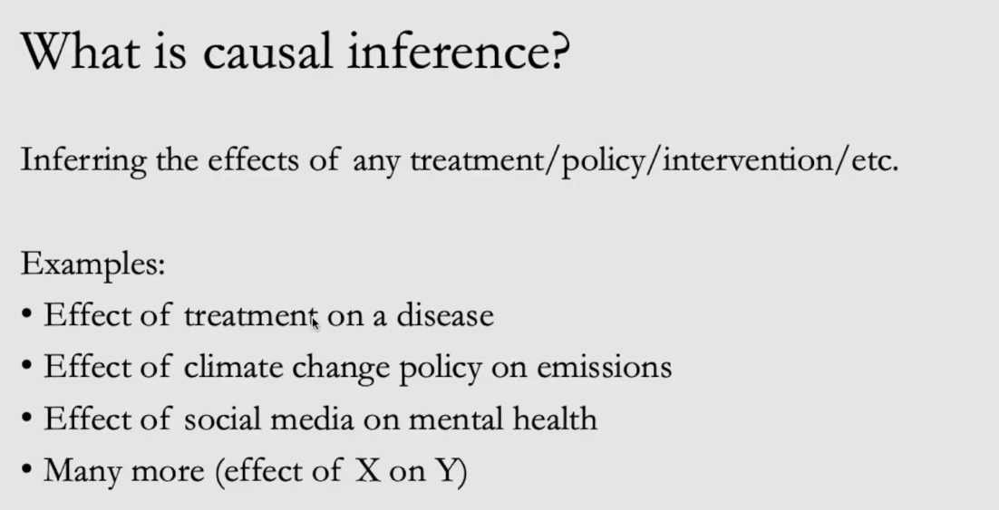

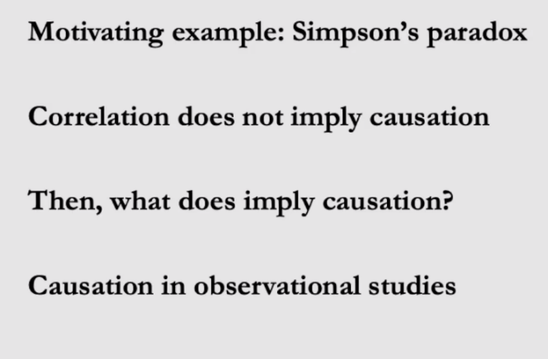

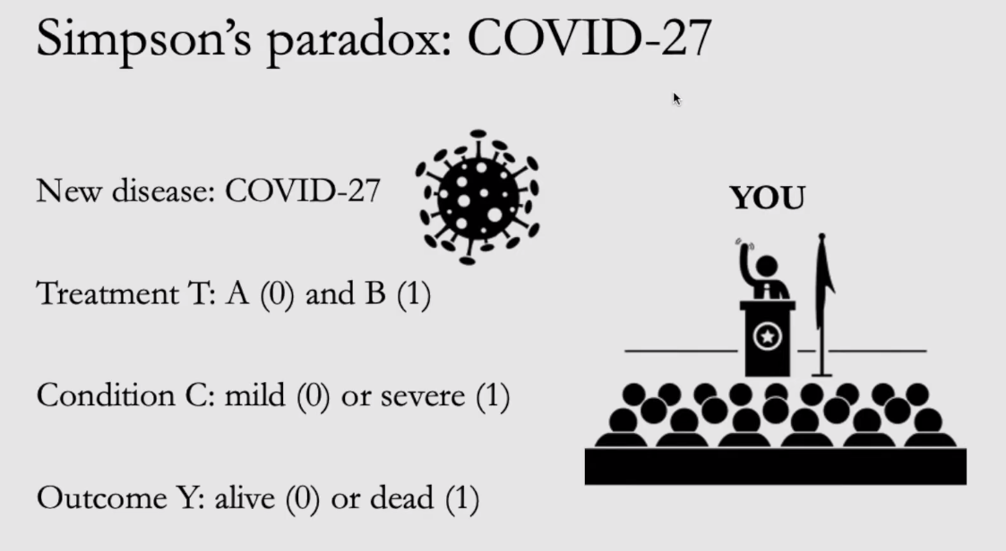

One way table:

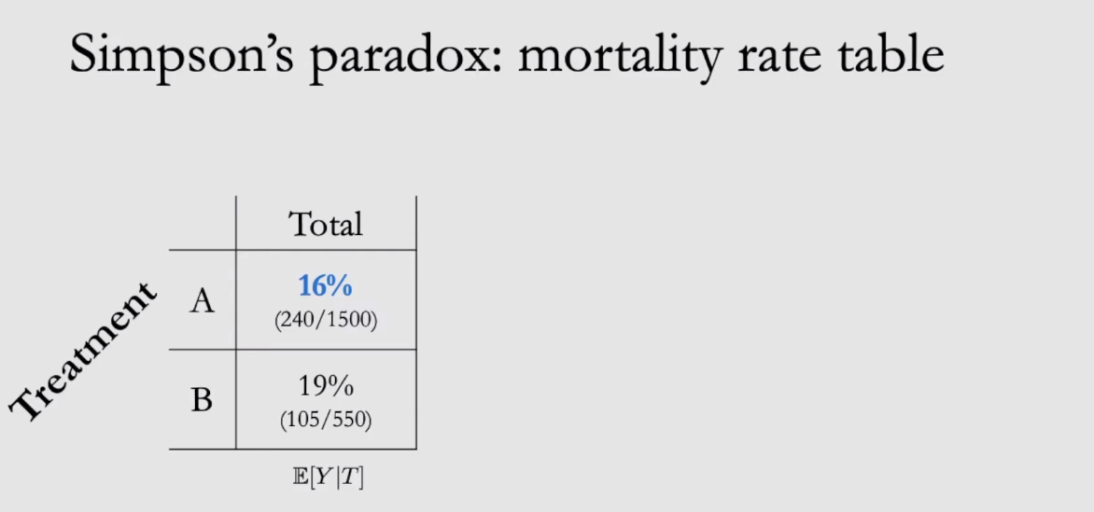

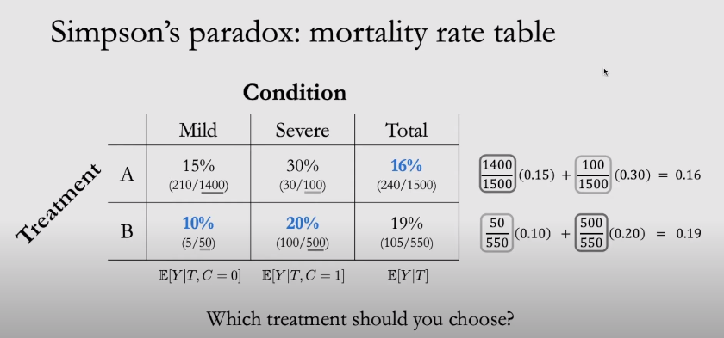

C🡪 Condition, T🡪 Treatment, Y🡪 Outcome.

Mild people got Treatment A and Severe case will get Treatment B.

In Scenario 1, Treatment B should be preferred.!! As the mortality rate for sever cases is less

Casual Graph🡪 condition is the cause of treatment

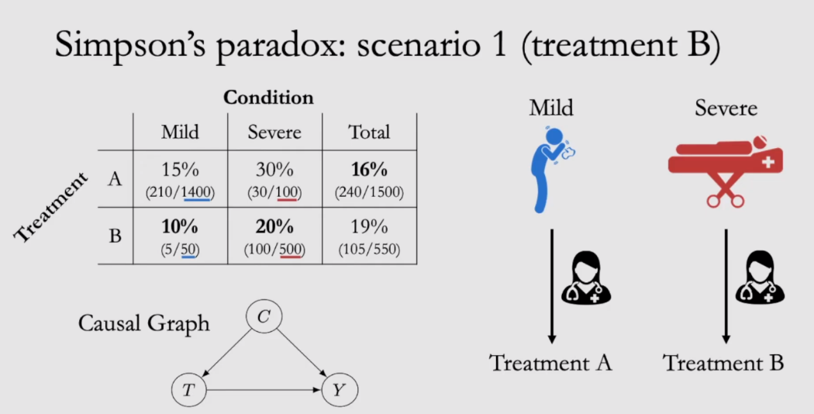

In scenario 2, the waiting time for Treatment B is high compared to Treatment A.

Hence in this scenario, Treatment A is preferred.

Casual Graph🡪Treatment is the cause of condition

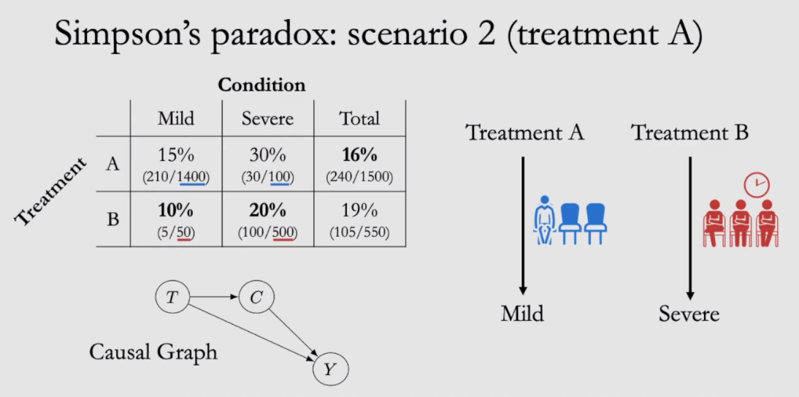

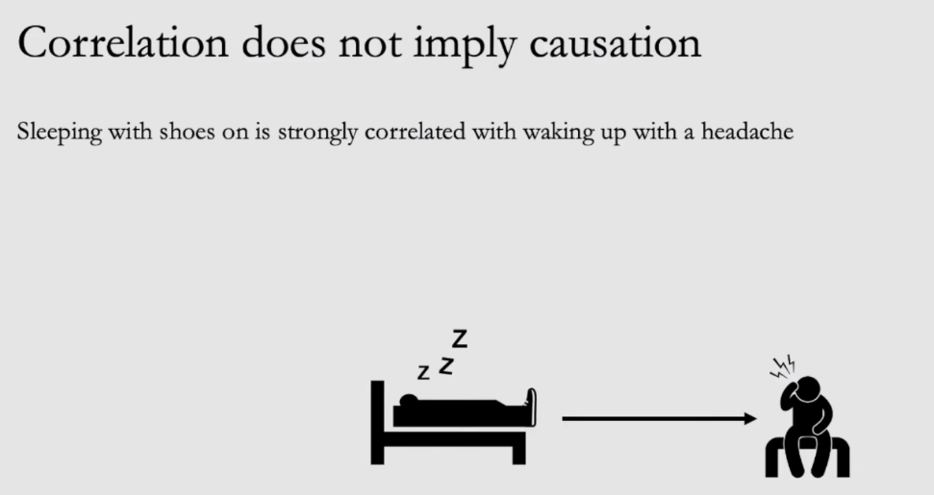

When we do more research to get the cause, we got if a person drinking the night before and going sleep, then they are getting the headache.

In statistics, a confounder is a variable that influences both the dependent variable and independent variable, causing a spurious association.

**Cause**🡪 Purposefully changing this variable changes the pattern of the outcome

Jumping too fast to the cause is not good. Based on the observation data, we can’t do the cause.

**Confounded**🡪 Causes changes in both the outcome and the predictor ie. Confounded will give you wrong information.

We might mis leaded based on the below graph, that smokers have more lung capacity

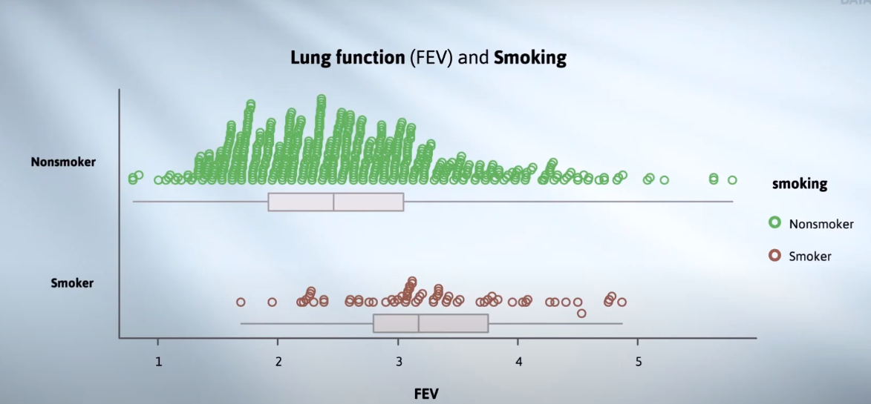

Age is the confounding Variable. When it is compared with age, we get the real picture

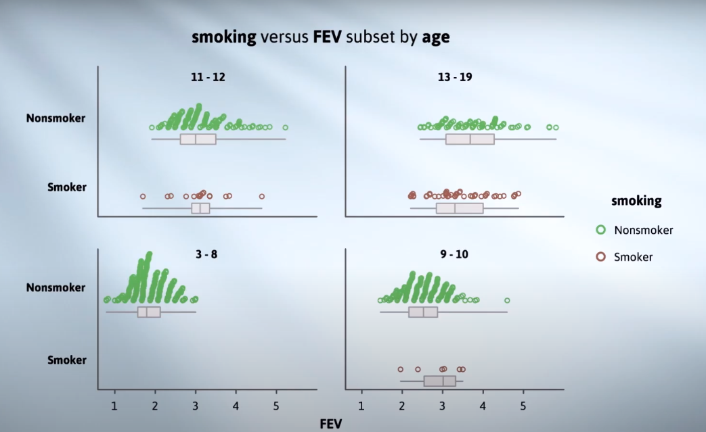

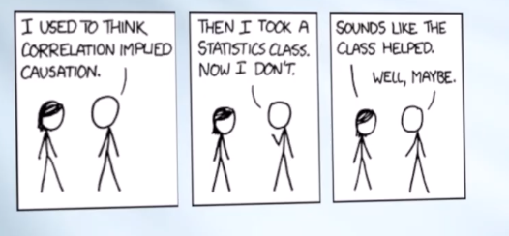

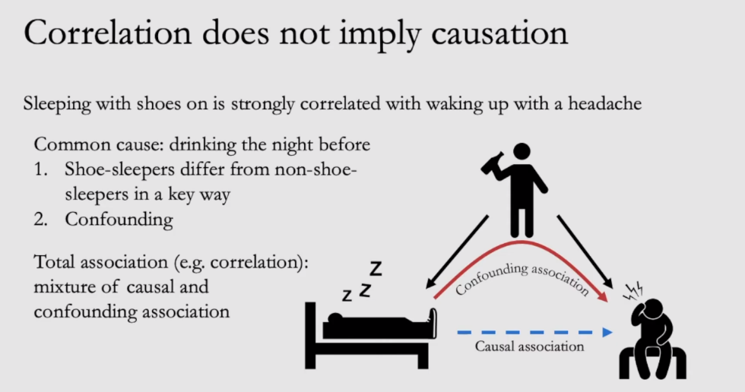

Available heuristic🡪 means coffee can cause headache etc.

Motivated Reasoning🡪 Talking with the in-laws caused me the headache.

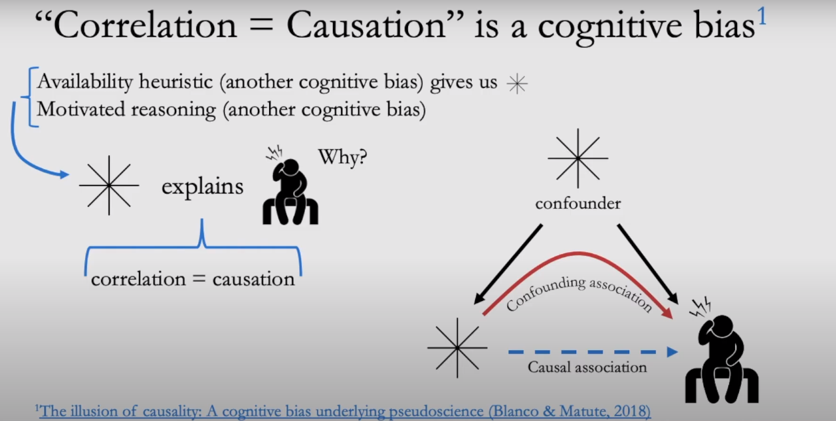

Correlation does not imply causation, see the below funny example,

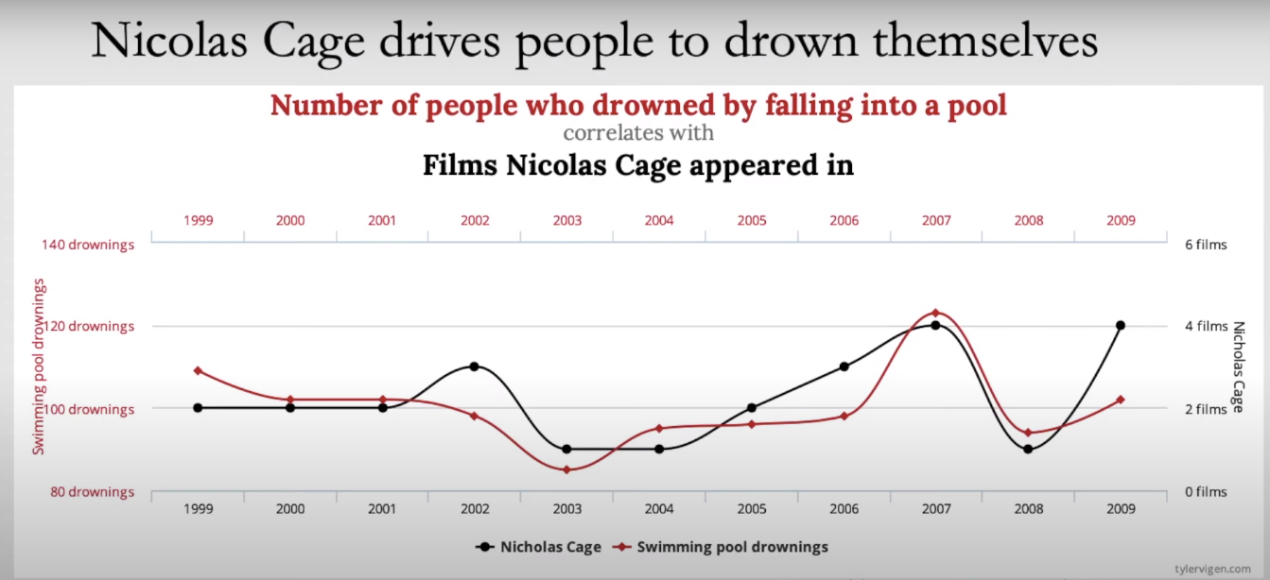

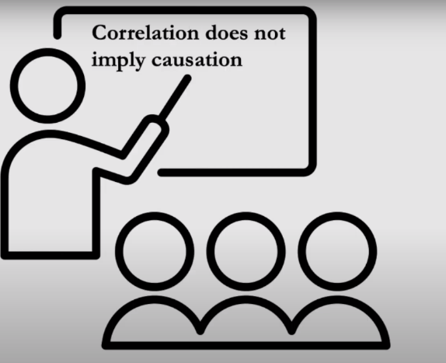



Causal effect, if you take the pill then your headache might go

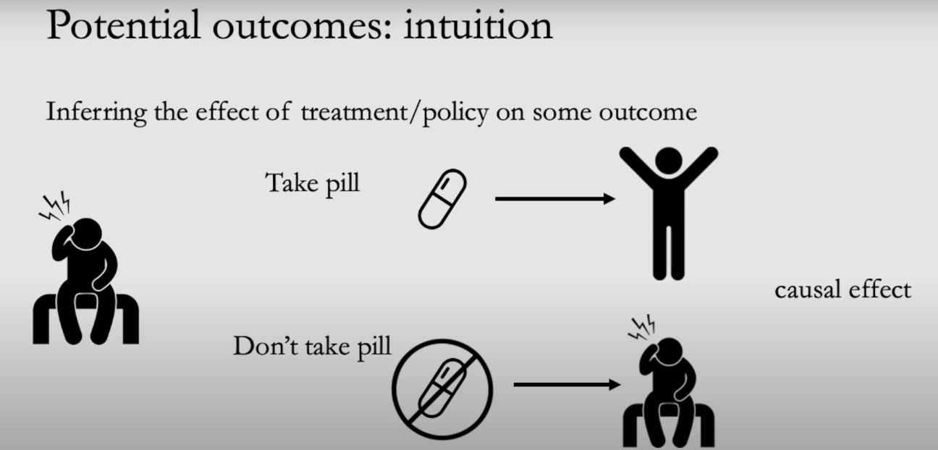

No Causal effect, without taking pill, the headache goes away.

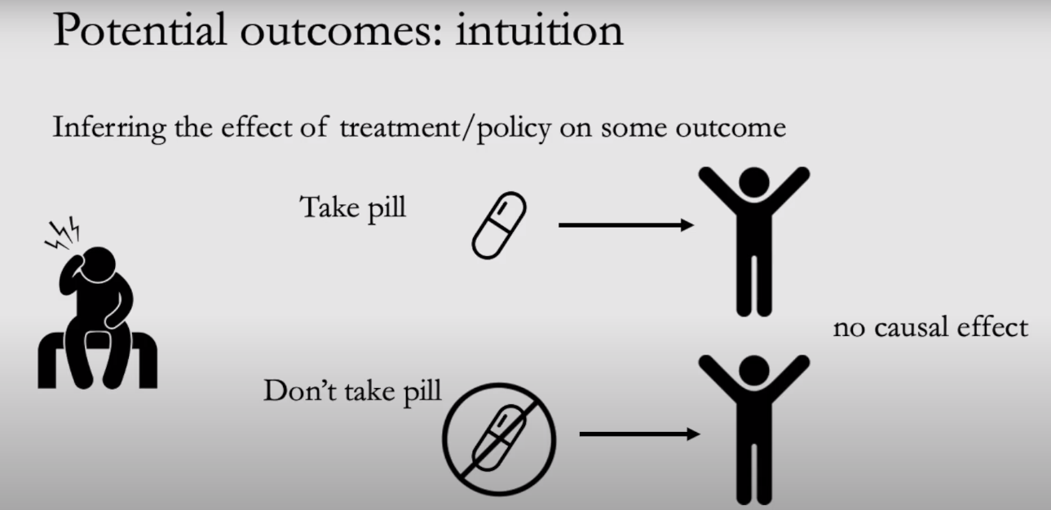

Y (1) 🡪 If you take the pill, your headaches goes away

Y (0)🡪 if you don’t take the pill, your headaches still stays

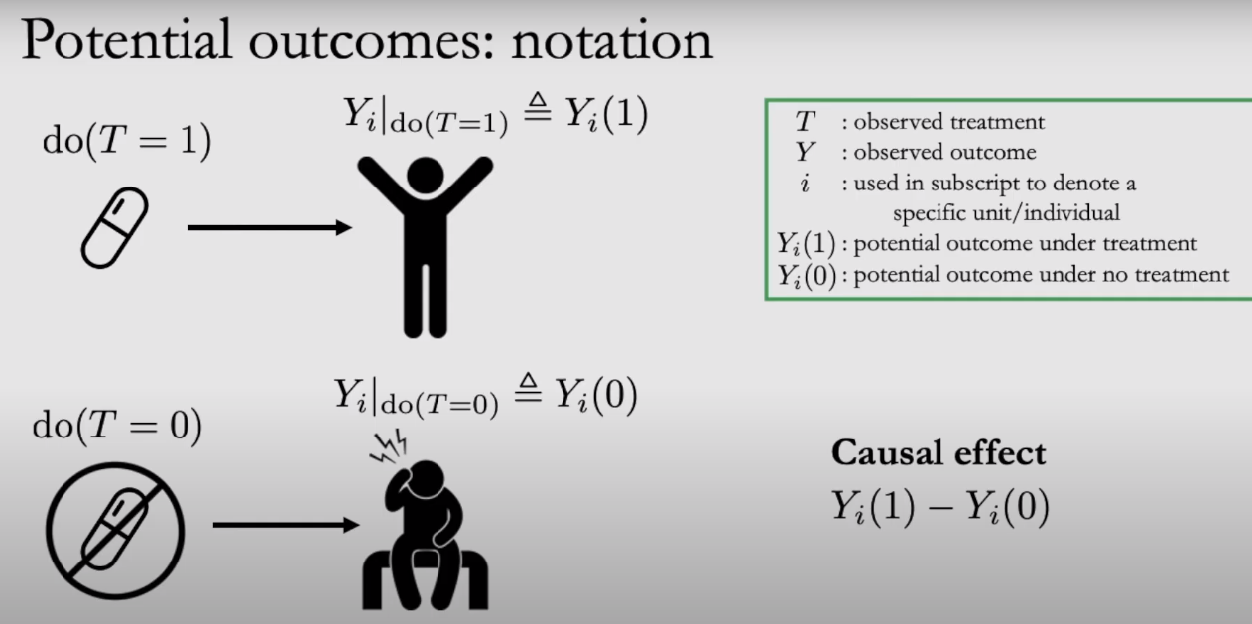

If you don’t take the pill, you cant observe what will happen if you take the pill

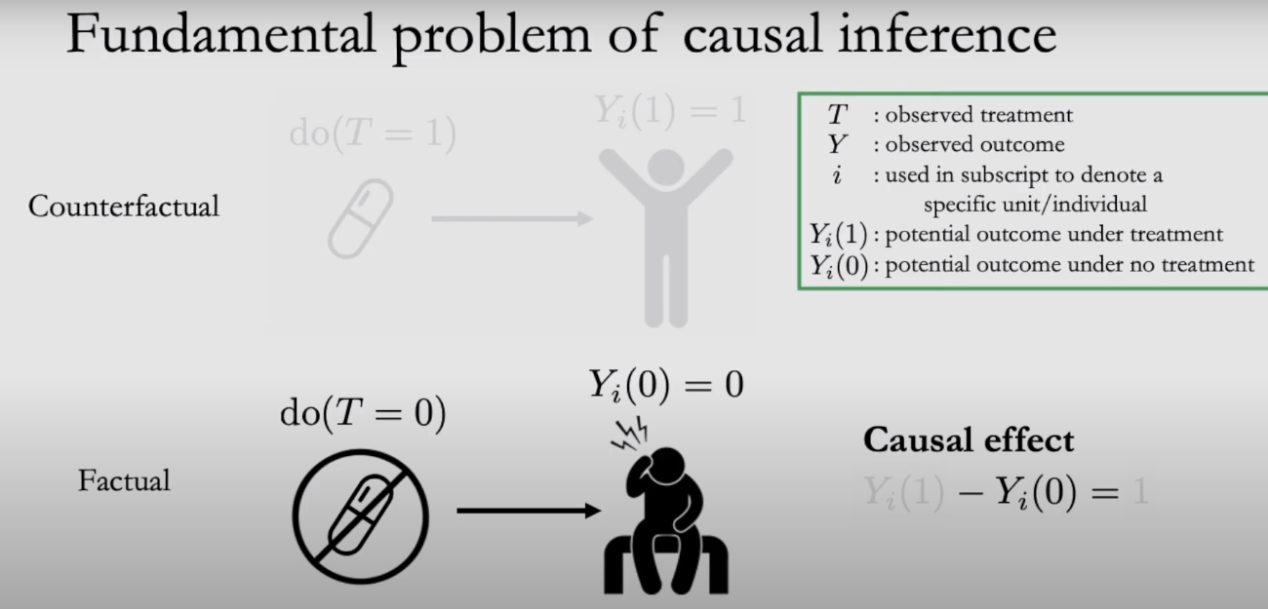

If you take the pill, you can’t observe what will happen if you don’t take pill. Ie. will naturally goes away.

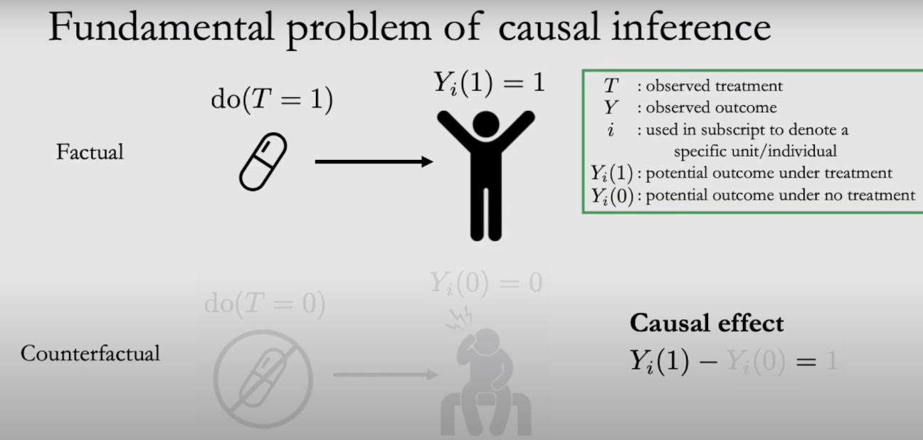

Here, i denotes individual treatment.

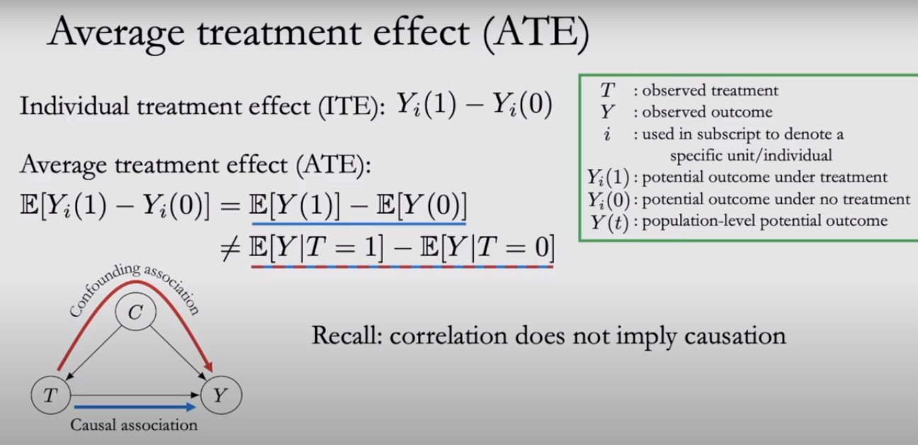

**Randomization makes the groups comparable. Then there will be causal association.**

**EG:** Balance age group for comparing non-smokers. Headache comparisons included drinkers on the both side

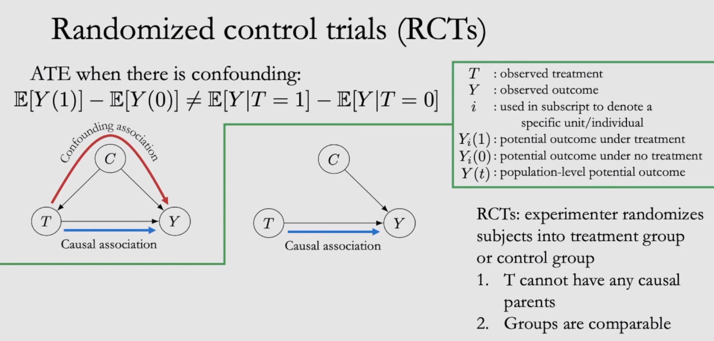

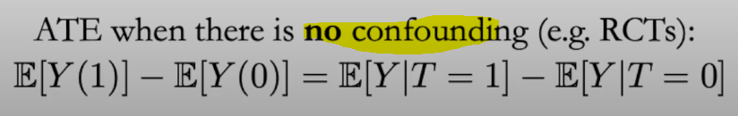

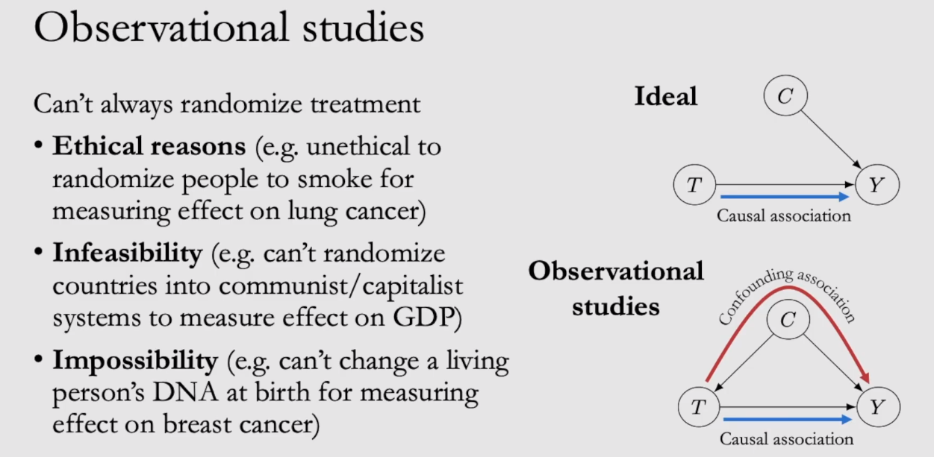

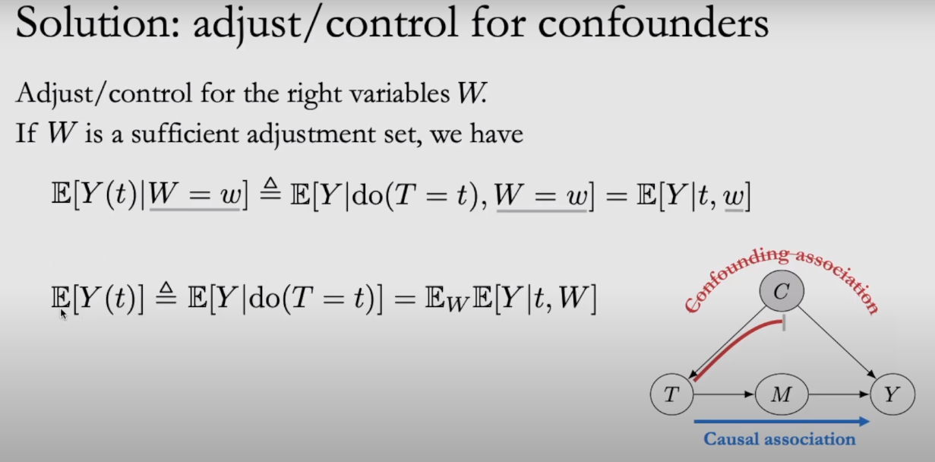

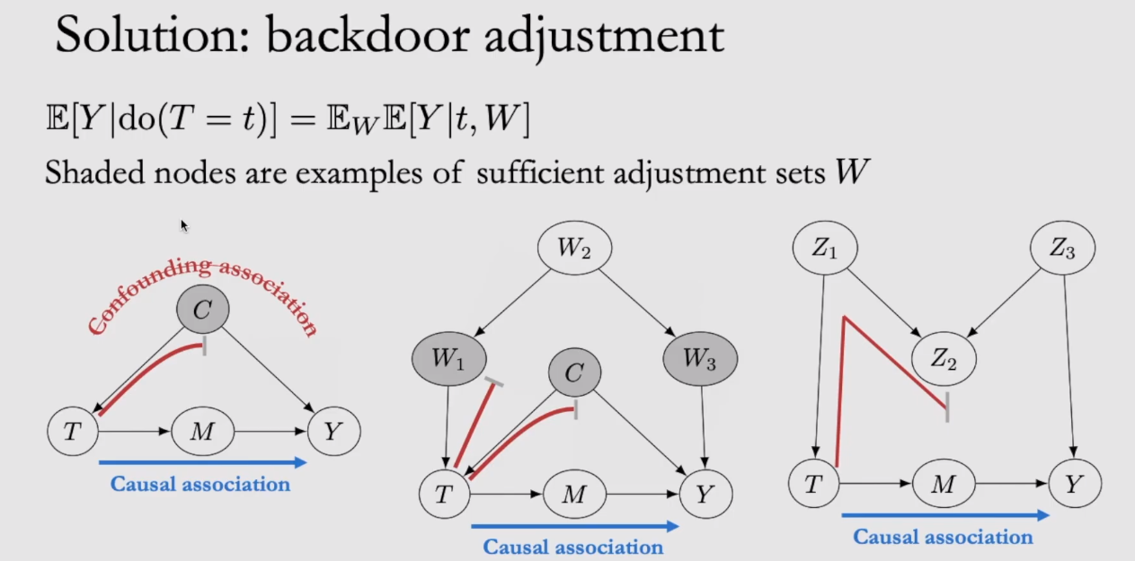

Using marginal distribution, (1400+50) = 1450

